**HR Data**

**Goal:** An HR attrition analysis in SQL and Power BI to show what are the factors, lead employees leaving an organization. The analysis looks at gender, marital status, age, education level as well job role and a business traveler to see how they relate with attrition. Companies can use this data to build retention strategies, drive higher employee satisfaction and ultimately improve overall business performance. Understanding these external factors that are leading to an increase in attrition accomplishes is the first step taken towards addressing why people are leaving your organization and working toward a more positive and productive work environment.

**Create a Table to import the data**

create table hrdata

(

emp_no int8 PRIMARY KEY,

gender varchar(50) NOT NULL,

marital_status varchar(50),

age_band varchar(50),

age int8,

department varchar(50),

education varchar(50),

education_field varchar(50),

job_role varchar(50),

business_travel varchar(50),

employee_count int8,

attrition varchar(50),

attrition_label varchar(50),

job_satisfaction int8,

active_employee int8

)

**Import Data in Table Using Query**

COPY hrdata FROM 'D:\hrdata.csv' DELIMITER ',' CSV HEADER;

**Checking the data after importing**

Select * from hrdata;

**KPI 1: Employee Count:**

select sum(employee_count) as Employee_Count from hrdata;

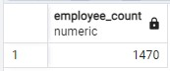

**Conclusion-** There are total of 1,470 employees in the organization.

**KPI 2: Attrition Count:**

select count(attrition) from hrdata where attrition='Yes';

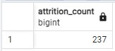

**Conclusion-** 237 employees have left the company.

**KPI 3: Attrition Rate:**

select

round (((select count(attrition) from hrdata where attrition='Yes')/

sum(employee_count)) * 100,2)

from hrdata;

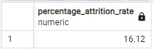

**Conclusion-** 237 employees lead to approximately 16% of attrition rate.

**KPI 4: Active Employee:**

select sum(employee_count) - (select count(attrition) from hrdata where attrition='Yes') from hrdata;

*OR*

select (select sum(employee_count) from hrdata) - count(attrition) as active_employee from hrdata

where attrition='Yes';

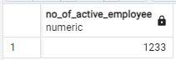

**Conclusion-** 1,233 employees remain actively employed in the company.

**KPI 5: Average Age:**

select round(avg(age),0) from hrdata;

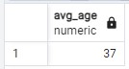

**Conclusion-** The average age of employees is 37 years.

**Attrition by Age Band**

SELECT age_band, sum(employee_count) AS employee_count FROM hrdata

GROUP BY age_band

order by age_band;

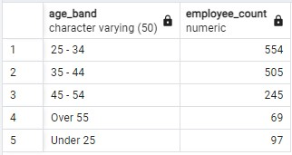

**Conclusion-** The age band of 25–34 years has the highest attrition count with 554 employees, indicating that younger employees may be more likely to switch jobs, while it decreases with age: 35–44 years (505), 45–54 years (245), and over 55 years (69).

**No of Employee by Age**

SELECT age, sum(employee_count) AS employee_count FROM hrdata

GROUP BY age

order by age;

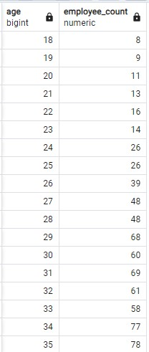 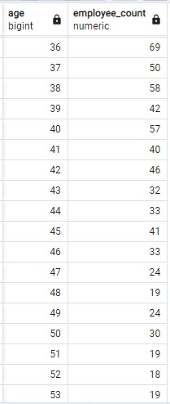 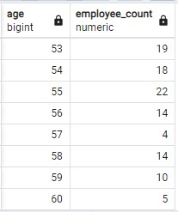

**Conclusion-** Employees aged between 18 to 34 experience a higher rate of attrition, with the peak occurring at ages 29, 30, 31, and 34, showing attrition counts of 68 to 77 employees.

**Attrition by Gender**

select gender, count(attrition) as attrition_count from hrdata

where attrition='Yes'

group by gender

order by count(attrition) desc;

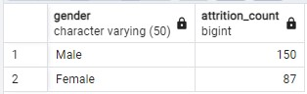

**Conclusion-** Males have a higher attrition count than female employees.

**Marital Status wise Attrition**

select marital_status, count(attrition), round((cast (count(attrition) as numeric) /

(select count(attrition) from hrdata where attrition= 'Yes')) * 100, 2) as percentage_attrition_count from hrdata

where attrition='Yes'

group by marital_status

order by count(attrition) desc;

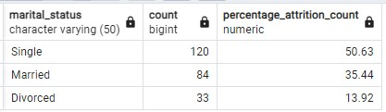

**Conclusion-** Single employees have the highest attrition rate at 50.63%, suggesting that single employees are more likely to leave,while married employees have a 35.44% attrition rate, followed by divorced employees at 13.92%.

**Department wise Attrition**

select department, count(attrition), round((cast (count(attrition) as numeric) /

(select count(attrition) from hrdata where attrition= 'Yes')) * 100, 2) as percentage_attrition_count from hrdata

where attrition='Yes'

group by department

order by count(attrition) desc;

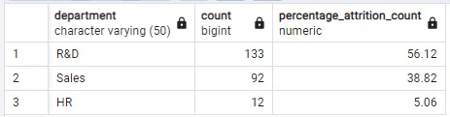

**Conclusion-** R&D Department has the highest attrition rate at 56.12%, followed by Sales with 38.82%. The HR department has the lowest attrition rate at 5.06%.

**Education wise Attrition**

select education, count(attrition) as attrition_count

from hrdata

where attrition='Yes'

group by education

order by count(attrition) desc;

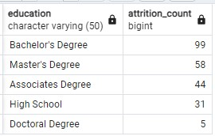

**Conclusion-** Employees holding a Bachelor’s Degree (99 attrition count) have the highest attrition, followed by Master’s Degree (58) and Associates Degree (44). This suggests that employees with higher education levels may have more opportunities and are more likely to leave.

**Education Field wise Attrition**

select education_field, count(attrition) as attrition_count

from hrdata

where attrition='Yes'

group by education_field

order by count(attrition) desc;

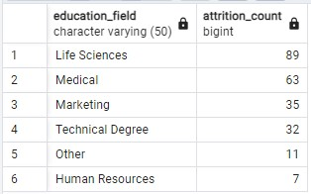

**Conclusion-** Employees from Life Sciences and Medical backgrounds have the highest attrition counts at 89 and 63, respectively, indicating potential challenges in retaining talent in these fields.

**Job Role wise Attrition**

select job_role, count(attrition) as attrition_count

from hrdata

where attrition='Yes'

group by job_role

order by count(attrition) desc;

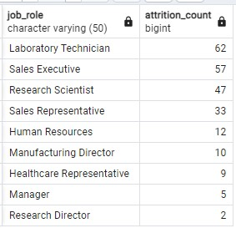

**Conclusion-** Laboratory Technicians (62), Sales Executives (57), and Research Scientists (47) experience the highest attrition rates, which could indicate

* intense workload,
* rapid technological advancements,
* work-life balance issues,
* lack of recognition,
* limited compensation increases,
* toxic work culture,
* lack of support

**Business Travel wise Attrition**

select business_travel, count(attrition), round((cast (count(attrition) as numeric) /

(select count(attrition) from hrdata where attrition= 'Yes')) * 100, 2) as percentage_attrition_count from hrdata

where attrition='Yes'

group by business_travel

order by count(attrition) desc;

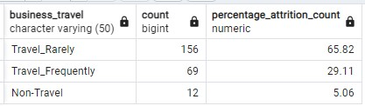

**Conclusion-** Employees who Travel Rarely have the highest attrition rate at 65.82%, possibly due to finding it harder to maintain a work-life balance, especially if travel disrupts personal time, contributing to dissatisfaction and higher attrition, followed by those who travel frequently at 29.11%. Non-traveling employees have the lowest attrition rate at 5.06%.

**Job Satisfaction Rating**

-- Run this query first to activate the cosstab() function in postgres

CREATE EXTENSION IF NOT EXISTS tablefunc;

-- Then run this to get o/p-

SELECT *

FROM crosstab(

'SELECT job_role, job_satisfaction, sum(employee_count)

FROM hrdata

GROUP BY job_role, job_satisfaction

ORDER BY job_role, job_satisfaction'

) AS ct(job_role varchar(50), one numeric, two numeric, three numeric, four numeric)

ORDER BY job_role;

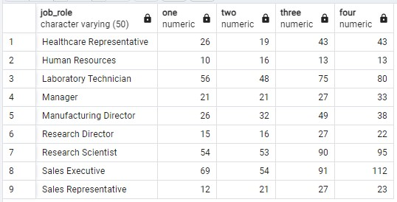

**Conclusion-**

1. Sales Executive: The highest number of employees with the top satisfaction rating (112 in "four") and a significant

number in "three" (91).

1. Laboratory Technician: Most employees fall in the "three" (75) and "four" (80) satisfaction categories, indicating overall higher satisfaction.
2. Research Scientist: A large portion of employees are highly satisfied, with 95 in the "four" rating and 90 in the "three" categories.
3. Human Resources: Lower distribution across the satisfaction categories, with the highest count in "two" (16).
4. Healthcare Representative: Satisfaction is relatively evenly distributed, with 43 employees each in "three" and "four" ratings.
5. Manager: Satisfaction levels are spread across, with a notable number in "four" (33).
6. Sales Representative: Distribution is balanced across satisfaction categories, with more employees in "two" (21) and "four" (23).

**Attrition Rate by Gender for different Age Group**

select age_band, gender, count(attrition) as attrition,

round((cast(count(attrition) as numeric) / (select count(attrition) from hrdata where attrition = 'Yes')) * 100,2)

as percentage_attrition_count

from hrdata

where attrition = 'Yes'

group by age_band, gender

order by age_band, gender desc;

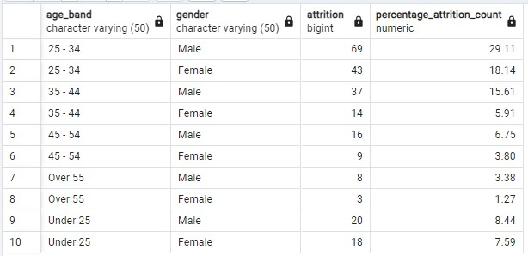

**Conclusion-** The highest attrition rate is of males in all categories and is in the "25 - 34" age band for males (29.11%), followed by females in the same age band (18.14%), and decreases significantly in older age groups, with minimal attrition seen in the "Over 55" group.